Section 0

Git and Github as local VCS

1.

Answer:

mkdir project_dir

cd project_dir/

2.

Answer

$ git init

Initialized empty Git repository in G:/Capgemini Sanjay/Asignment/Git_Github/project_dir/.git/

3.

Answer:

touch index.html

4.

Answer:

$ git status

On branch master

No commits yet

Untracked files:

(use "git add <file>..." to include in what will be committed)

index.html

nothing added to commit but untracked files present (use "git add" to track)

5.

Answer

$ git add index.html

6.

Answer:

$ git commit -m 'index file has commited'

[master (root-commit) 39ae288] index file has commited

1 file changed, 0 insertions(+), 0 deletions(-)

create mode 100644 index.html

7.

Answer:

touch info.txt

8.

Answer:

$ git status

On branch master

Changes not staged for commit:

(use "git add <file>..." to update what will be committed)

(use "git restore <file>..." to discard changes in working directory)

modified: index.html

Untracked files:

(use "git add <file>..." to include in what will be committed)

info.txt

no changes added to commit (use "git add" and/or "git commit -a")

9.

Answer:

touch .gitignore

10.

Answer:

$ git status

On branch master

Changes not staged for commit:

(use "git add <file>..." to update what will be committed)

(use "git restore <file>..." to discard changes in working directory)

modified: index.html

Untracked files:

(use "git add <file>..." to include in what will be committed)

.gitignore

no changes added to commit (use "git add" and/or "git commit -a")

11.

Answer:

$ git commit -a -m 'index file with changes'

[master 69045a4] index file with changes

1 file changed, 15 insertions(+)

12.

Answer

$ git log

commit 69045a4d01af53f4a34fcc5e0322008dcb0c7f5a (HEAD -> master)

Author: sanjayprasadF5 <sanjayprasad2321998@gmail.com>

Date: Mon May 17 13:08:48 2021 +0530

index file with changes

commit 39ae28887c8d3e6e82c0aaa6670b5c426fa3307b

Author: sanjayprasadF5 <sanjayprasad2321998@gmail.com>

Date: Mon May 17 12:54:37 2021 +0530

index file has commited

13.

Answer:

$ git status

On branch master

Changes not staged for commit:

(use "git add <file>..." to update what will be committed)

(use "git restore <file>..." to discard changes in working directory)

modified: index.html

Untracked files:

(use "git add <file>..." to include in what will be committed)

.gitignore

no changes added to commit (use "git add" and/or "git commit -a")

14.

Answer:

git checkout -- .

15.

Answer:

$ git status

On branch master

Changes not staged for commit:

(use "git add <file>..." to update what will be committed)

(use "git restore <file>..." to discard changes in working directory)

modified: index.html

Untracked files:

(use "git add <file>..." to include in what will be committed)

.gitignore

no changes added to commit (use "git add" and/or "git commit -a")

16.

Answer:

$ git add index.html

17.

Answer:

$ git reset HEAD index.html

Unstaged changes after reset:

M index.html

18.

Answer:

$ alias my_add='git add'

19.

Answer:

my_add index.html

$ git commit -m'index file with new heading level 2'

[master 4969144] index file with new heading level 2

1 file changed, 1 insertion(+)

20.

Answer:

$ git reset HEAD~

Unstaged changes after reset:

M index.html

Git Branching

Section 1

HTML

21.

Answer:

22.

Answer:

mkdir Assignments

cd Assignments/

23.

Answer:

touch README.txt

24.

Answer:

$ git commit -a -m 'Readme with content'

[master 5a966af] Readme with content

1 file changed, 1 insertion(+)

25.

Answer:

$ git branch html-assignments

26.

Answer:

$ git checkout html-assignments

Switched to branch 'html-assignments'

27.

Answer:

cp index.html Assignments/

28.

Answer:

$ git add index.html

$ git commit -m'index in assignment'

[html-assignments 5a6f870] index in assignment

1 file changed, 16 insertions(+)

create mode 100644 Assignments/index.html

29.

Answer:

$ git status

On branch html-assignments

Changes not staged for commit:

(use "git add <file>..." to update what will be committed)

(use "git restore <file>..." to discard changes in working directory)

modified: index.html

Untracked files:

(use "git add <file>..." to include in what will be committed)

../.gitignore

no changes added to commit (use "git add" and/or "git commit -a")

30.

Answer:

$ git commit -m'h3 level heading added to file'

[html-assignments adc340c] h3 level heading added to file

1 file changed, 1 insertion(+)

31.

Answer:

$ git checkout master

Switched to branch 'master'

32.

Answer:

$ git add README.txt

$ git commit -m'changes readme'

[master f5cfcff] changes readme

1 file changed, 3 insertions(+)

create mode 100644 Assignments/README.txt

33.

Answer:

$ git checkout html-assignments

34.

Answer:

35.

Answer:

$ git commit -a -m'paragraph added in the index file'

[html-assignments 4b7b530] paragraph added in the index file

1 file changed, 1 insertion(+)

36.

Answer:

$ git checkout master

Switched to branch 'master'

37.

Answer:

$ git merge html-assignments

Merge made by the 'recursive' strategy.

Assignments/index.html | 18 ++++++++++++++++++

1 file changed, 18 insertions(+)

create mode 100644 Assignments/index.html

38.

Answer:

$ git branch -d html-assignments

Deleted branch html-assignments (was 4b7b530).

Section 2

CSS

1.

Answer:

$ git branch css-assignment

2.

Answer:

$ git checkout css-assignment

Switched to branch 'css-assignment'

3.

Answer:

cp style.css Assignments/

4.

Answer:

$ git commit -m'css file h1 red color'

[css-assignment c7d7ce7] css file h1 red color

1 file changed, 3 insertions(+)

create mode 100644 Assignments/style.css

5.

Answer:

6.

Answer:

$ git commit -m'heading properties is css'

[css-assignment 31a52a5] heading properties is css

2 files changed, 6 insertions(+), 1 deletion(-)

7.

Answer:

$ git checkout master

Switched to branch 'master'

8.

Answer:

$ git commit -a -m'readme changes'

[master 32ef7b9] readme changes

1 file changed, 3 insertions(+), 1 deletion(-)

9.

Answer:

$ git checkout css-assignment

Switched to branch 'css-assignment'

10.

Answer:

11.

Answer:

$ git commit -a -m'padding in style'

[css-assignment 26ea7da] padding in style

1 file changed, 3 insertions(+)

12.

Answer:

$ git checkout master

Switched to branch 'master'

13.

Answer:

$ git merge css-assignment

14.

Answer:

$ git branch -d css-assignment

Deleted branch css-assignment (was 26ea7da).

Section 3

Javascript

1.

Answer:

$ git branch js-assignments

2.

Answer:

$ git checkout js-assignments

Switched to branch 'js-assignments'

3.

Answer:

$ cp myapp1.js Assignments/

$ cp myapp2.js Assignments/

4.

Answer:

$ git add myapp1.js myapp2.js

$ git commit -m'app1 and 2'

[js-assignments 0cf29dc] app1 and 2

2 files changed, 0 insertions(+), 0 deletions(-)

create mode 100644 Assignments/myapp1.js

create mode 100644 Assignments/myapp2.js

5.

Answer:

6.

Answer:

$ git add -A

$ git commit -m'readme updated'

[js-assignments 02366b1] readme updated

4 files changed, 5 insertions(+)

create mode 100644 .gitignore

create mode 100644 myapp1.js

create mode 100644 myapp2.js

create mode 100644 style.css

7.

Answer:

$ git checkout master

Switched to branch 'master'

8.

Answer:

$ git commit -a -m'readme updated'

[master b6eb6d1] readme updated

1 file changed, 1 insertion(+), 8 deletions(-)

9.

Answer:

$ git checkout js-assignments

Switched to branch 'js-assignments'

10.

Answer:

11.

Answer:

$ git commit -a -m'console in app1 and 2'

[js-assignments 175a3c8] console in app1 and 2

2 files changed, 2 insertions(+)

12.

Answer:

$ git checkout master

Switched to branch 'master'

13.

Answer:

$ git merge js-assignments

14.

Answer:

$ git branch -d js-assignments

Deleted branch js-assignments (was 175a3c8).

Section 3:

Git Remoting

$ git push origin master

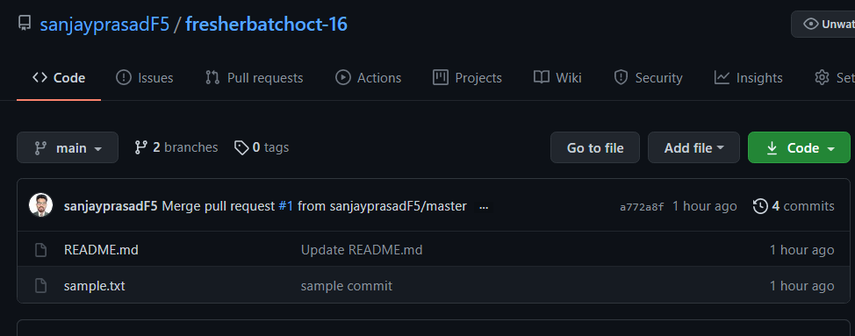

Section 4

Eclipse

